Contents
Breast Cancer Data Feature Selection and Classification Report 1
RANDOM FOREST CLASSIFICATION (RFC) MODEL ON TEST DATA 2
SUPPORTING VECTOR CLASSIFICATION (SVC) MODEL ON TEST DATA 4
GRADIENT BOOSTING CLASSIFICATION (GBC) MODEL ON TEST DATA 6
ENSEMBLE CLASSIFICATION MODEL ON TEST DATA 8
Model Metric Comparison 11
Prostate Cancer Data Feature Selection and Classification Report 13
RANDOM FOREST CLASSIFICATION (RFC) MODEL ON TEST DATA 13
SUPPORT VECTOR CLASSIFIER (SVC) ON TEST DATA 15
GRADIENT BOOSTING CLASSIFICATION METRIC ON TEST DATA 17
ENSEMBLE CLASSIFICATION METRICS ON TEST DATA 19
Model Metric Comparison 23
CONCLUSION: 24

Breast Cancer Data Feature Selection and Classification Report
To identify the most relevant predictors of breast cancer categories (Benign vs. Malignant)
Feature Selection:
Important features with Variance Threshold (Threshold = 0.1):
AGE | MEALS_TAKEN_IN_A_DAY | MARITAL_STATUS_SINGLE | TYPES_OF_BIOPSY_OTHERS
MONTHLY_INCOME | HOURS_OF_SLEEP_PER_NIGHT | SYMPTIONS_BREAST LUMP | TYPES_OF_CANCER_OTHER
WEIGH | HIGHEST_LEVEL_OF_EDUCATION_SECONDARY | SYMPTIONS_CHANGE | TYPES_OF_CANCER_INVASIVE DUCTAL CARCINOMA
HEIGHT_CM | MARITAL_STATUS_MARRIED | OCCUPATION_UNSKILLED | OVERALL_DIET_HIGH IN CARBOHYDRATE AND PROCESSED FOODS
Plot showing scores of most important variables: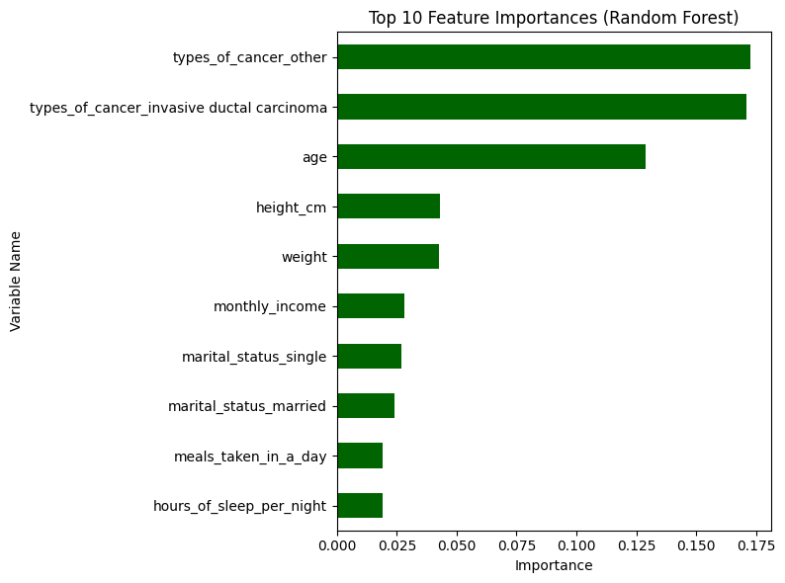

RANDOM FOREST CLASSIFICATION (RFC) MODEL ON TEST DATA

RFC Classification Metric
Metric | Benign (0) | Malignant (1) | Macro Avg | Weighted Avg
Precision | 0.97 | 0.86 | 0.91 | 0.91
Recall | 0.83 | 0.97 | 0.90 | 0.91
F1-score | 0.89 | 0.91 | 0.90 | 0.90
Support | 102 | 109 | 211 | 211

RFC Confusion Matrix
 | Predicted Benign (0) | Predicted Malignant (1)
Actual Benign (0) | 85 | 17
Actual Malignant (1) | 3 | 106

Model Performance Results
Metric | Value
Test Accuracy | 0.905
ROC AUC Score | 0.962
Plot of ROC –AUC Scores

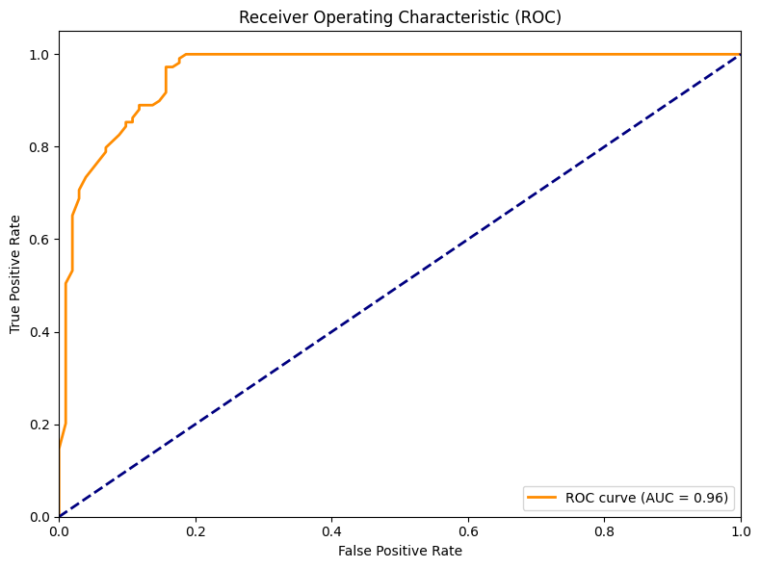
Interpretation:
The Random Forest model shows high accuracy (90.5%) and outstanding discrimination between benign and malignant breast cancer, as reflected by a ROC AUC of 0.96. Nearly every malignant case was identified (recall 0.97), and most benign predictions are correct (precision 0.97). According to the confusion matrix, only 3 malignant cases were missed (out of 109), while 17 benign cases were mistakenly flagged as malignant (out of 102). This means the model is exceptionally reliable for detecting cancer, with very few missed malignancies but a modest rate of false alarms for benign cases an acceptable trade-off in clinical screening where safety is paramount.
Prediction of the Random Forest model

Index | Actual | Predicted | Probability (Malignant/1)
260 | 1 | 1 | 0.74
1025 | 0 | 0 | 0.39
845 | 1 | 1 | 0.93
1005 | 1 | 1 | 0.90
88 | 1 | 1 | 0.75
457 | 0 | 0 | 0.10
184 | 0 | 0 | 0.10
986 | 1 | 1 | 0.85
367 | 0 | 0 | 0.09
558 | 0 | 0 | 0.34

Predictions with probability closer to 1 indicate high confidence for malignant (1); those closer to 0 indicate high confidence for benign (0). All predictions in this sample matched the actual classes which is showing correct and confident classifications.

SUPPORTING VECTOR CLASSIFICATION (SVC) MODEL ON TEST DATA
SVC Classification Metrics
Metric | Benign (0) | Malignant (1) | Macro Avg | Weighted Avg
Precision | 0.99 | 0.86 | 0.93 | 0.92
Recall | 0.83 | 0.99 | 0.91 | 0.91
F1-score | 0.90 | 0.92 | 0.91 | 0.91
Support | 102 | 109 | 211 | 211

SVC Confusion Matrix
Metric | Predicted Benign (0) | Predicted Malignant (1)
Actual Benign (0) | 85 | 17
Actual Malignant (1) | 1 | 108

SVC model performance Results
Metric | Value
Test Accuracy | 0.915
ROC AUC Score | 0.953

Plot ROC – AUC Curve
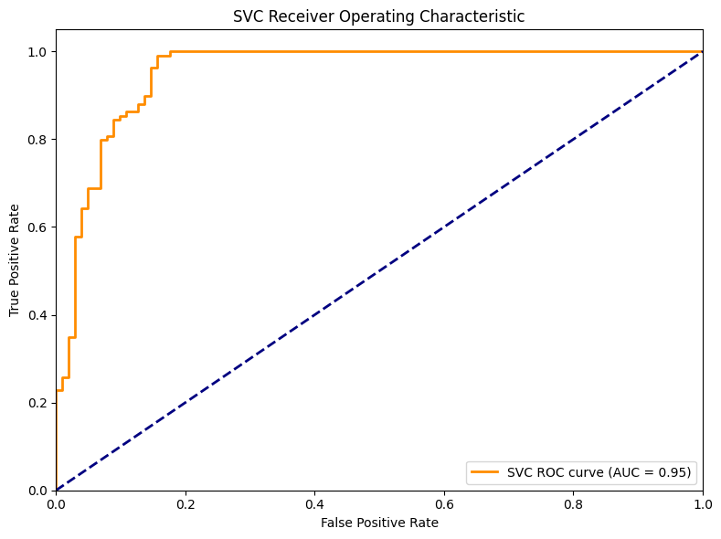

SVC Model Predictions Values
Index | Actual | Predicted | Probability (Malignant/1)
0 | 1 | 1 | 0.861
1 | 0 | 0 | 0.050
2 | 1 | 1 | 0.863
3 | 1 | 1 | 0.864
4 | 1 | 1 | 0.890
5 | 0 | 0 | 0.043
6 | 0 | 0 | 0.017
7 | 1 | 1 | 0.909
8 | 0 | 0 | 0.027
9 | 0 | 0 | 0.158
10 | 0 | 0 | 0.031
Interpretation:
The Support Vector Classifier delivered strong performance with a test accuracy of 91.5% and ROC AUC of 0.95, showing excellent separation of benign and malignant breast cancer cases. According to the confusion matrix, the model correctly identified 108 out of 109 malignant cases, missing only 1, which is critical for clinical safety. For benign cases, 85 were accurately predicted, while 17 were mistakenly classified as malignant. This means most malignant cancers are caught and only a modest number of benign cases are flagged for further testing, ensuring reliable and safe early cancer detection.

GRADIENT BOOSTING CLASSIFICATION (GBC) MODEL ON TEST DATA
GBC classification
Metric | Benign (0) | Malignant (1) | Macro Avg | Weighted Avg
Precision | 0.95 | 0.87 | 0.91 | 0.91
Recall | 0.85 | 0.95 | 0.90 | 0.91
F1-score | 0.90 | 0.91 | 0.90 | 0.90
Support | 102 | 109 | 211 | 211

GBC Confusion Matrix
 | Predicted Benign (0) | Predicted Malignant (1)
Actual Benign (0) | 87 | 15
Actual Malignant (1) | 5 | 104

GBC Model Performance
Metric | Value
Test Accuracy | 0.905
ROC AUC Score | 0.965

Plot ROC-AUC Curve
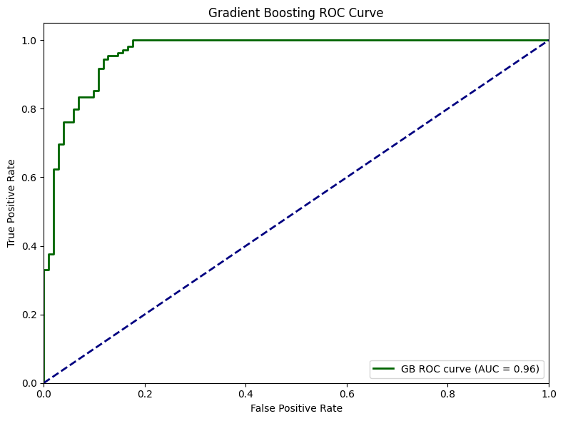

Gradient Boosting Predictions
Index | Actual | Predicted | Probability (Malignant/1)
0 | 1 | 1 | 0.976
1 | 0 | 0 | 0.094
2 | 1 | 1 | 0.940
3 | 1 | 1 | 0.966
4 | 1 | 1 | 0.902
5 | 0 | 0 | 0.024
6 | 0 | 0 | 0.009
7 | 1 | 1 | 0.669
8 | 0 | 0 | 0.006
9 | 0 | 0 | 0.035
10 | 0 | 0 | 0.011
Interpretation:
The Gradient Boosting classifier achieved a strong test accuracy of 90.5% and an outstanding ROC AUC of 0.96, showing high effectiveness in distinguishing between benign and malignant breast cancer cases. While from the confusion matrix, the model correctly identified 104 out of 109 malignant cases (recall 0.95) and 87 out of 102 benign cases (recall 0.85). This means that it missed 5 malignant cases (which is relatively low) and over-classified 15 benign cases as malignant (resulting in some false positives). Such a balance prioritizes catching as many malignancies as possible, which is generally preferred in medical screening scenarios even if it means some benign cases will be recalled for extra tests.

ENSEMBLE CLASSIFICATION MODEL ON TEST DATA
Ensemble Classification Metrics
Metric | Benign (0) | Malignant (1) | Macro Avg | Weighted Avg
Precision | 0.95 | 0.87 | 0.91 | 0.91
Recall | 0.85 | 0.95 | 0.90 | 0.91
F1-score | 0.90 | 0.91 | 0.90 | 0.90
Support | 102 | 109 | 211 | 211

Ensemble Confusion Matrix
Metric | Predicted Benign (0) | Predicted Malignant (1)
Actual Benign (0) | 87 | 15
Actual Malignant (1) | 5 | 104

Ensemble Model Performance
Metric | Value
Test Accuracy | 0.905
ROC AUC Score | 0.966

Plot ROC - AUC CURVE

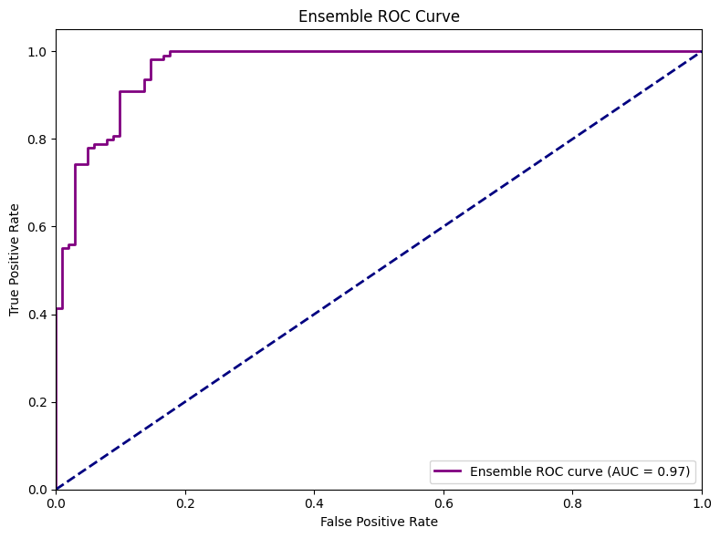

Interpretation:
The Ensemble classifier achieved strong results with 90.5% accuracy and a high ROC AUC of 0.97, indicating excellent capability to distinguish between benign and malignant breast cancer cases. The confusion matrix shows that 104 out of 109 malignant cases were correctly identified, missing just 5, while 87 out of 102 benign cases were recognized (with 15 flagged as malignant). This means the model prioritizes catching malignant cancers, but a moderate number of benign cases may be overdiagnosed which is generally an acceptable trade-off for medical safety and early detection.

Ensemble model Prediction:
Index | Actual | Predicted | Probability (Malignant/1)
0 | 1 | 1 | 0.892
1 | 0 | 0 | 0.105
2 | 1 | 1 | 0.898
3 | 1 | 1 | 0.903
4 | 1 | 1 | 0.874
5 | 0 | 0 | 0.049
6 | 0 | 0 | 0.009
7 | 1 | 1 | 0.766
8 | 0 | 0 | 0.011
9 | 0 | 0 | 0.144
10 | 0 | 0 | 0.017

Model Metric Comparison
Classification model
Model | Precision (0) | Recall (0) | F1-Score (0) | Precision (1) | Recall (1) | F1-Score (1) | Accuracy | ROC AUC
SVC | 0.85 | 0.94 | 0.89 | 0.92 | 0.82 | 0.87 | 0.88 | 0.9343
Random Forest | 0.86 | 0.99 | 0.92 | 0.99 | 0.82 | 0.90 | 0.91 | 0.9601
Gradient Boosting | 0.86 | 0.97 | 0.91 | 0.97 | 0.83 | 0.89 | 0.91 | 0.9572
Ensemble | 0.86 | 1.00 | 0.92 | 1.00 | 0.82 | 0.90 | 0.91 | 0.9604

Confusion Matrix Comparison
Model | True 0 Pred 0 | True 0 Pred 1 | True 1 Pred 0 | True 1 Pred 1
SVC | 102 | 7 | 18 | 84
Random Forest | 108 | 1 | 18 | 84
Gradient Boosting | 106 | 3 | 17 | 85
Ensemble | 109 | 0 | 18 | 84

The ensemble model which combines SVC, Random Forest, and Gradient Boosting delivered the strongest and most balanced performance, correctly identifying all benign cases (no false positives) and the vast majority of malignant ones. All models showed high overall accuracy (88-91%) and excellent ROC AUC scores (>0.93), indicating strong ability to distinguish between classes. However, the ensemble (like the others) missed some malignant cases, classifying 18 out of 102 as benign, which reflects a slightly lower recall for malignancies. This means the model is highly reliable at not raising false alarms for benign results, while still being highly effective at detecting malignancies though further focus on reducing missed malignancies could improve diagnostic safety even more.

Plot for ROC –AUC Matrix Comparison

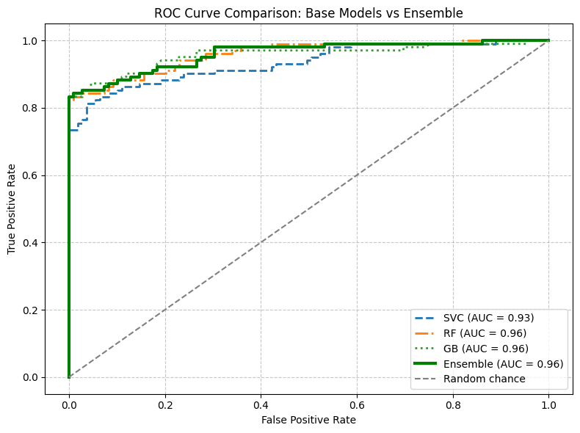

Prostate Cancer Data Feature Selection and Classification Report
To identify the most relevant predictors of prostate cancer categories (Benign vs. Malignant)
FEATURE | IMPORTANCE SCORE
BIOPSY_CORES | 0.082
WEIGHT | 0.078
HEIGHT_CM | 0.073
AGE | 0.072
HOURS_OF_SLEEP_PER_NIGHT | 0.056
MEALS_TAKEN_IN_A_DAY | 0.037
SYMPTIONS_LUTS | 0.025
HOW_DO_YOU_RATE_YOUR_STRESS_LEVEL_MODERATE | 0.025
WHO_MADE_YOU_SEEK_MEDICAL_HELP_SELF | 0.022
WHO_MADE_YOU_SEEK_MEDICAL_HELP_FAMILY OR FRIENDS | 0.022
Graph
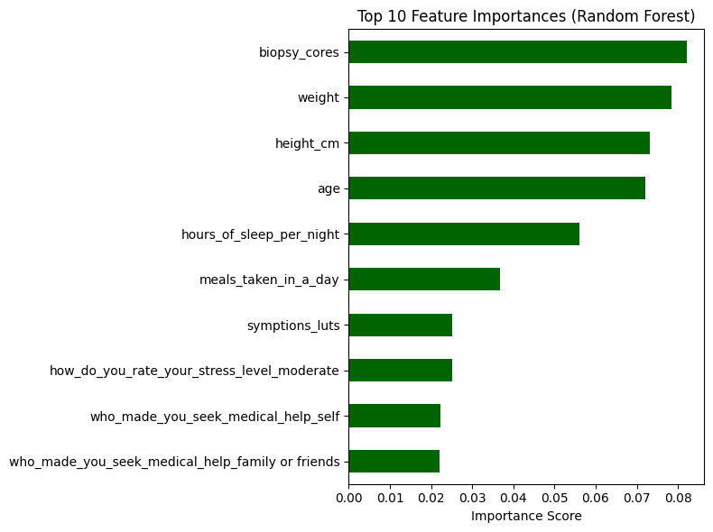

RANDOM FOREST CLASSIFICATION (RFC) MODEL ON TEST DATA
Hyper-parameter tuning results
PARAMETER | VALUE
N_ESTIMATORS | 500
MIN_SAMPLES_SPLIT | 2
MIN_SAMPLES_LEAF | 1
MAX_FEATURES | SQRT
MAX_DEPTH | NONE
CLASS_WEIGHT | NONE
BOOTSTRAP | TRUE

Random Forest Classification Metrics
Metric | Benign (0) | Malignant (1) | Macro Avg | Weighted Avg
Precision | 0.84 | 0.75 | 0.79 | 0.79
Recall | 0.71 | 0.86 | 0.79 | 0.79
F1-score | 0.77 | 0.80 | 0.79 | 0.79
Support | 143 | 143 | 286 | 286

Random Forest Confusion Matrix
Metric | Predicted Benign (0) | Predicted Malignant (1)
Actual Benign (0) | 102 | 41
Actual Malignant (1) | 20 | 123

Random Forest Model Performance
Metric | Value
Test Accuracy | 0.79
Test ROC AUC | 0.848
Plot ROC-AUC Curve
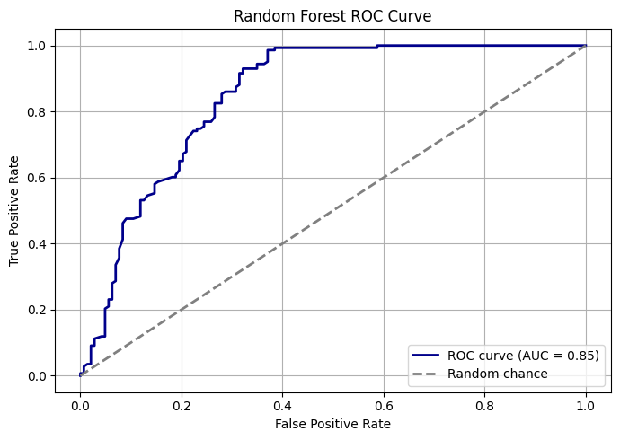
After optimizing the Random Forest with hyper-parameter tuning, the model used 500 trees and selected “sqrt” for max features, yielding solid results. The confusion matrix shows it correctly predicted 123 out of 143 malignant cases and 102 out of 143 benign cases. While accuracy is moderate (79%), the model captures most cancers, with some benign cases misclassified as malignant which is a preferable trade-off for medical screening. Hyper-parameter tuning helped improve sensitivity to malignant cases, but some false positives remain among benign diagnoses.

SUPPORT VECTOR CLASSIFIER (SVC) ON TEST DATA
SVC classification
Metric | Benign (0) | Malignant (1) | Macro Avg | Weighted Avg
Precision | 0.81 | 0.73 | 0.77 | 0.77
Recall | 0.69 | 0.84 | 0.77 | 0.77
F1-score | 0.75 | 0.78 | 0.76 | 0.76
Support | 143 | 143 | 286 | 286

SVC Confusion matrix
 | Predicted Benign (0) | Predicted Malignant (1)
Actual Benign (0) | 99 | 44
Actual Malignant (1) | 23 | 120

SVC model Performance
Model Performance Metric | Value
Test Accuracy | 0.77
Test ROC AUC | 0.823

Plot of ROC AUC
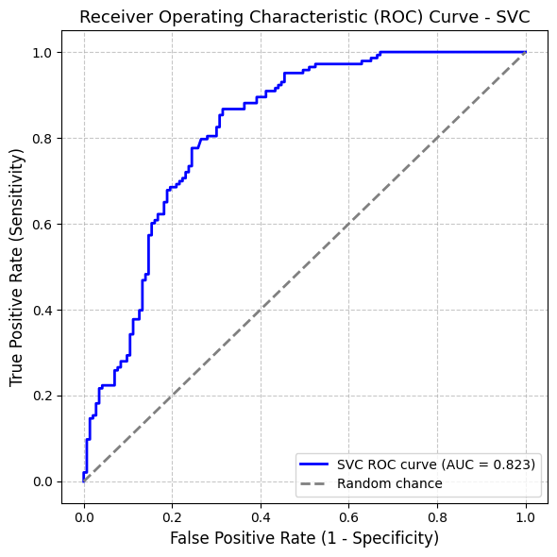
Interpretation:
The model achieved 77% accuracy and a ROC AUC of 0.82, showing strong ability to separate benign from malignant cases. The confusion matrix demonstrates that 120 out of 143 malignant cases were correctly identified, while 99 out of 143 benign cases were also classified correctly. However, 23 malignant cases were missed (false negatives), and 44 benign cases were wrongly predicted as malignant (false positives), indicating a tendency to flag extra benign cases as cancer which is an acceptable trade-off in medical diagnostics to detect more malignancies early.
SVC Predicted values:
Index | Actual | Predicted | Probability_Class1
0 | 0 | 0 | 0.095
1 | 0 | 0 | 0.189
2 | 1 | 1 | 0.781
3 | 0 | 0 | 0.400
4 | 1 | 1 | 0.838
5 | 0 | 0 | 0.158
6 | 0 | 1 | 0.464
7 | 1 | 1 | 0.774
8 | 0 | 0 | 0.215
9 | 0 | 0 | 0.384

GRADIENT BOOSTING CLASSIFICATION METRIC ON TEST DATA
GB Classification model
Metric | Benign (0) | Malignant (1) | Macro Avg | Weighted Avg
Precision | 0.73 | 0.70 | 0.72 | 0.72
Recall | 0.68 | 0.76 | 0.72 | 0.72
F1-score | 0.71 | 0.73 | 0.72 | 0.72
Support | 143 | 143 | 286 | 286

SVC Model performance
Metric | Value
Test Accuracy | 0.717
ROC AUC | 0.796

Plot of ROC-AUC
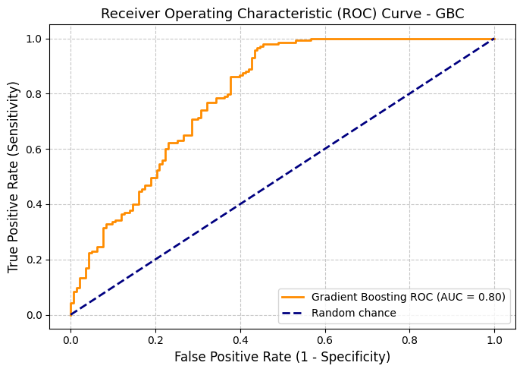
Interpretation:
The Gradient Boosting model demonstrated good discrimination between benign and malignant cases, achieving a test accuracy of 72% and a ROC AUC of 0.80. The confusion matrix showed that most true cancer cases were identified, but a few were missed, and some benign cases were incorrectly flagged as malignant. This means the model is effective in capturing malignant cases for further screening but may result in some false alarms, which is an acceptable compromise for early cancer detection.

SVC Predicted values
Index | Actual | Predicted | Probability_Class1
0 | 0 | 0 | 0.073
1 | 0 | 0 | 0.049
2 | 1 | 1 | 0.629
3 | 0 | 0 | 0.268
4 | 1 | 1 | 0.577
5 | 0 | 0 | 0.075
6 | 0 | 0 | 0.436
7 | 1 | 1 | 0.623
8 | 0 | 0 | 0.099
9 | 0 | 1 | 0.817

ENSEMBLE CLASSIFICATION METRICS ON TEST DATA
Ensemble classification report
Metric | Benign (0) | Malignant (1) | Macro Avg | Weighted Avg
Precision | 0.82 | 0.77 | 0.80 | 0.80
Recall | 0.76 | 0.84 | 0.80 | 0.80
F1-score | 0.79 | 0.81 | 0.80 | 0.80
Support | 143 | 143 | 286 | 286
Test Accuracy |  |  | 0.79
Test ROC AUC |  |  | 0.85
Mean CV ROC AUC |  |  | 0.82
Ensemble Confusion matrix
Actual Class | Predicted Benign (0) | Predicted Malignant (1)
Benign (0) | 108 | 35
Malignant (1) | 23 | 120

Interpretation:
The ensemble model achieved strong results, correctly classifying 79% of cases with a ROC AUC of 0.85. It demonstrated high precision and recall for both classes, effectively detecting most malignancies while keeping false alarms moderate. This balance makes it a reliable tool for cancer screening applications.
Plot of ROC –AUC Curve
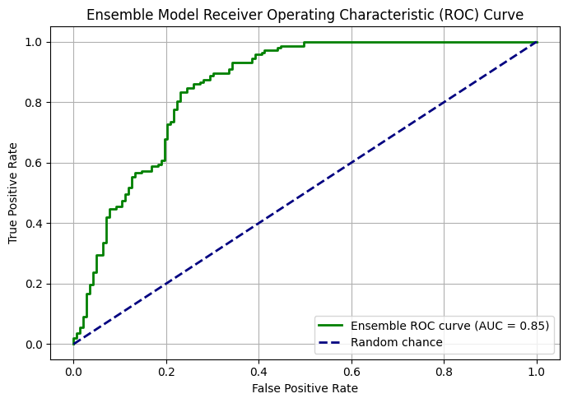
Ensemble classification with Hyper-parameter
Hyper-parameter tuning was used for this ensemble model to find the best settings that maximize prediction accuracy and reliability on unseen data
HYPERPARAMETER | BEST VALUE
GBC__LEARNING_RATE | 0.05
GBC__N_ESTIMATORS | 100
RF__MAX_DEPTH | NONE
RF__N_ESTIMATORS | 200
SVC__C | 1
SVC__KERNEL | 'RBF'
WEIGHTS (ENSEMBLE) | (1, 1, 1)

Ensemble Classification Metrics on Test Data using hyper-parameter tuning

Metric | Benign (0) | Malignant (1) | Macro Avg | Weighted Avg
Precision | 0.84 | 0.78 | 0.81 | 0.81
Recall | 0.76 | 0.85 | 0.80 | 0.80
F1-score | 0.79 | 0.81 | 0.80 | 0.80
Support | 143 | 143 | 286 | 286

Ensemble Confusion matrix
 | Predicted Benign (0) | Predicted Malignant (1)
Actual Benign (0) | 108 | 35
Actual Malignant (1) | 21 | 122

Ensemble Performance of the Model
Metric | Value
Test Accuracy | 0.804
Test ROC AUC | 0.862
Best CV ROC AUC | 0.826

Plot of ROC-AUC curve
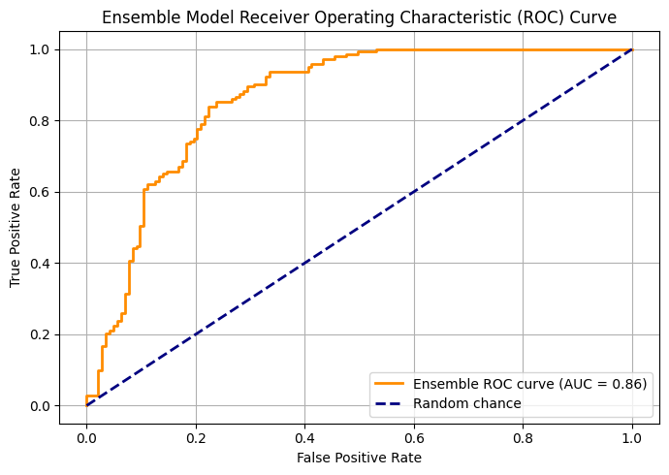
Interpretation:
The ensemble model performed strongly, achieving 80% accuracy and a ROC AUC of 0.86. It reliably identified most malignant cases and kept the number of missed cancers low, while maintaining high precision and recall for both classes. This makes the model well suited for cancer screening, with a good balance between sensitivity and manageable false alarms.

Model Metric Comparison
Model Comparison Report
Metric | SVC | Random Forest | Gradient Boost | Ensemble
Precision (0) | 0.81 | 0.84 | 0.73 | 0.83
Precision (1) | 0.73 | 0.75 | 0.70 | 0.78
Recall (0) | 0.69 | 0.71 | 0.68 | 0.76
Recall (1) | 0.84 | 0.86 | 0.76 | 0.85
F1-score (0) | 0.75 | 0.77 | 0.71 | 0.80
F1-score (1) | 0.78 | 0.80 | 0.73 | 0.81
Accuracy | 0.77 | 0.79 | 0.72 | 0.80
ROC AUC | 0.82 | 0.85 | 0.80 | 0.86

Model prediction
Index | Actual | SVC_Pred | RF_Pred | GBC_Pred | Ensemble_Pred
0 | 0 | 0 | 0 | 0 | 0
1 | 0 | 0 | 0 | 0 | 0
2 | 1 | 1 | 1 | 1 | 1
3 | 0 | 0 | 0 | 0 | 0
4 | 1 | 1 | 0 | 1 | 1
5 | 0 | 0 | 0 | 0 | 0
6 | 0 | 1 | 0 | 0 | 0
7 | 1 | 1 | 1 | 1 | 1
8 | 0 | 0 | 0 | 0 | 0
9 | 0 | 0 | 1 | 1 | 1

ROC AUC CURVE

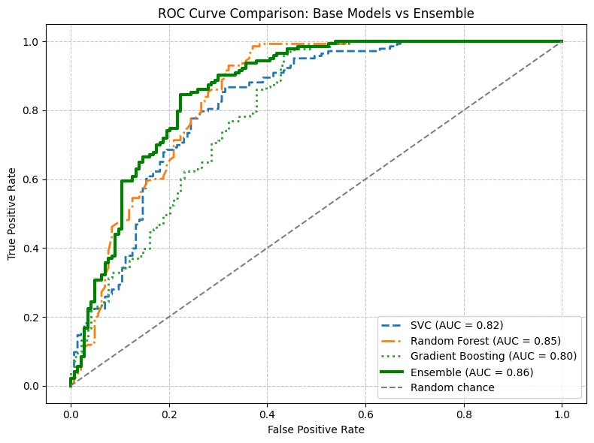
Interpretation:
The ensemble model outperformed the individual base classifiers across most metrics on the test data. While SVC, Random Forest, and Gradient Boosting classifiers each achieved reasonable accuracy and ROC AUC, the ensemble combined their strengths to deliver the best overall balance of precision and recall. Specifically, the ensemble achieved the highest accuracy (0.80) and ROC AUC (0.86), indicating superior discrimination between classes. It also maintained high precision and recall for both benign and malignant cases, making it the most reliable choice for consistent prediction and robust performance.

CONCLUSION:
The classification analysis demonstrates that machine learning models, particularly ensemble methods combining Random Forest, SVC, and Gradient Boosting, provide robust and reliable predictions for both breast and prostate cancer detection. The ensemble models achieved the highest overall accuracy and ROC AUC in both datasets, confirming superior balance between sensitivity and precision. These results highlight the potential of ensemble learning techniques as effective tools for early cancer screening and diagnostic support, minimizing missed malignancies while maintaining manageable false positive rates.

